**Assignment- Classification Algorithm**

**STEP 1:**

**3 stage Problem Identification:**

Stage1: Machine Learning

Stage2: Supervised Learning

Stage3: Classification

**STEP 2:**

**Basic information about Dataset:**

Total number of rows: 399

Total number of columns:25

**STEP 3:**

**Preprocessing method used for two columns:**

* Nominal Data

**STEP 4:**

**1. Support Vector Machine Checker:**

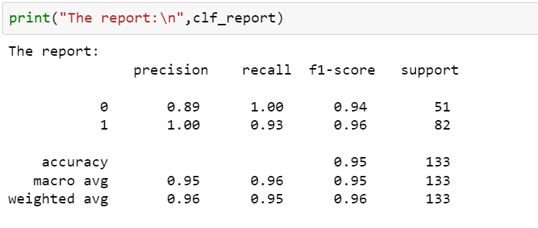

**2. Decision Tree Checker:**

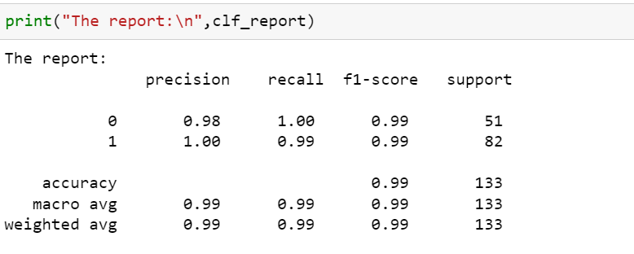

**3.Random Forest Classification**

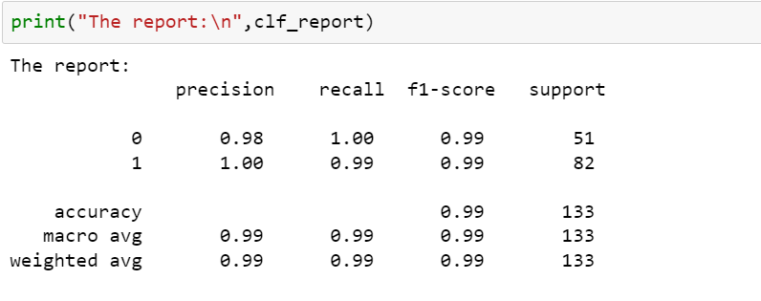

**4.Logistic Regression Classification**

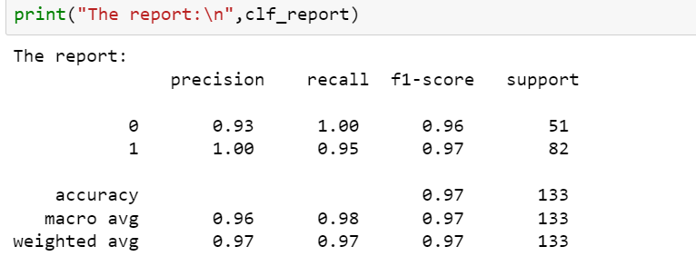

**5.KNN Classification kernel search**

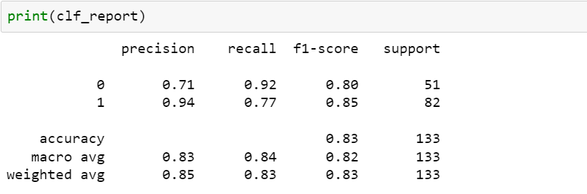

**6.Navie Bayes Classification kernel search**

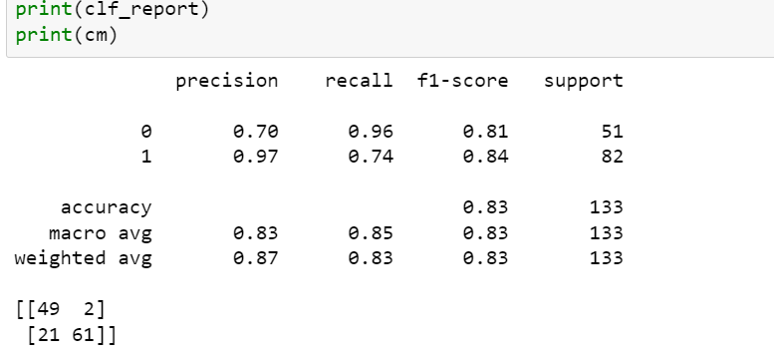

**STEP 5:**

**Good Model:**

* Decision Tree and Random Forest



**STEP 6:**

**Explanation**

**I suppose to say Decision Tree and Random Forest both gave me high value for the model and any of it can be used as a final model as of now.**